Grade 7 Accelerated · Unit 4 · Assessment  Solving Problems with Rational Numbers  Form A · 29 points · two class periods ANSWER KEY | Name  Date  Period

This assessment runs over two class periods. Stop when the period ends; you will continue from where you stopped.
Show your work. One point for each lettered part.
Part 1. Operations in Scientific Notation 12 points MA.8.NSO.1.5
If an earlier part is wrong, a later part still earns its point when the right operation is applied to your own earlier answer — but only if that work is on the page.
1. Add or subtract. Write each answer in scientific notation.
a. 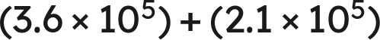 1 pt

Same power: add the coefficients.
b. 1 pt
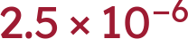
c. 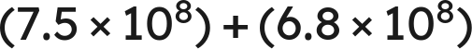 1 pt

 is the value; 14.3 is not less than 10, so it is not the answer.
d. 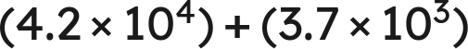 1 pt

.
Scoring: a 1 · b 1 · c 1 · d 1 = 4 points.

2. Multiply or divide. Write each answer in scientific notation.
a. 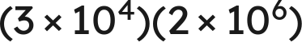 1 pt

b. 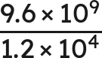 1 pt

c. 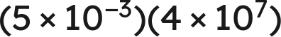 1 pt

 is not finished.
d. 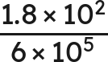 1 pt
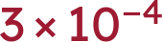
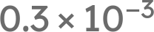 is not finished either.
Scoring: a 1 · b 1 · c 1 · d 1 = 4 points.

3. Which is the value of 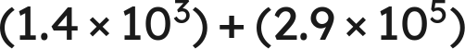 ? 1 pt
○ A. 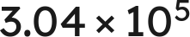
○ B. 
● C. 
○ D. 
C
Scoring: 1 point.

4. Select ALL of the expressions whose value is 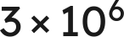. 1 pt
☒ A. 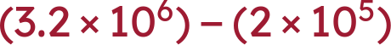
☐ B. 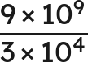
☒ C. 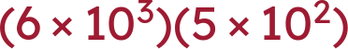
☒ D. 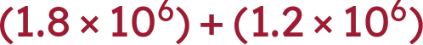
☐ E. 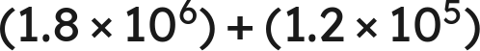
☒ F. 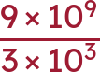
A, C, D and F
C gives , which is 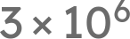 once it is finished. All four correct and nothing else for the point.
Scoring: 1 point.

5. Kendra writes . Name the two mistakes she made, and give the correct sum. 1 pt
She added the coefficients without first writing both numbers over the same power of ten, and she added the exponents. The correct sum is .
Both mistakes must be named for the point; one of the two is half the item. .
Scoring: 1 point.

6. A number is multiplied by 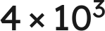 and the product is 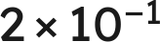. What was the number? Write your answer in scientific notation. 1 pt
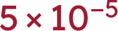
TRANSFER ITEM — not on the practice test. Same benchmark, a surface nobody rehearsed. 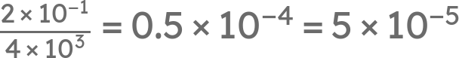. Working a product backwards across a sign change appears on no review and in no question bank; the point is for the finished form, so 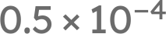 alone does not earn it.
Scoring: 1 point.

Part 2. Real-World Problems in Scientific Notation 4 points MA.8.NSO.1.6
If an earlier part is wrong, a later part still earns its point when the right operation is applied to your own earlier answer — but only if that work is on the page.
7. Solve. Write each answer in scientific notation. Do not round.
a. A rectangular plate measures 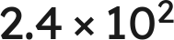 mm by 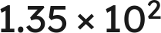 mm. Find its area. 1 pt
 square millimeters
Multiply the coefficients and add the exponents: 2.4 · 1.35 = 3.24, and .
b. A vehicle travels 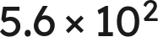 km in 8 hours. Find its average speed. 1 pt
 km/h
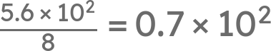, which is not finished: 0.7 is less than 1.
Scoring: a 1 · b 1 = 2 points.

8. Solve. Write each answer in scientific notation. Do not round.
a. Two lengths are measured:  mm and 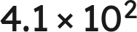 mm. Find their sum. 1 pt
 mm
Match the powers first: , and 6.25 + 0.41 = 6.66.
b. Two masses are measured: 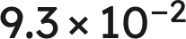 g and 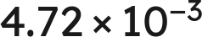 g. Find their difference. 1 pt
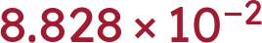 g
Match the powers first: , and 9.3 − 0.472 = 8.828.
Scoring: a 1 · b 1 = 2 points.

Part 3. The Order of Operations with Exponents and Radicals 13 points MA.8.NSO.1.7
If an earlier part is wrong, a later part still earns its point when the right operation is applied to your own earlier answer — but only if that work is on the page.
9. Evaluate each expression.
a. 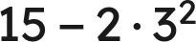 1 pt
−3
The power first, then the product, then the subtraction.
b. 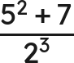 1 pt
4
32 over 8; the bar groups the whole numerator.
c. 36 ÷ 4 · 3 1 pt
27
One level, left to right: 9 · 3. Not 3.
d. 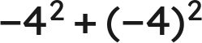 1 pt
0
−16 + 16. The parentheses decide what the exponent is attached to.
Scoring: a 1 · b 1 · c 1 · d 1 = 4 points.

10. Evaluate each expression.
a. 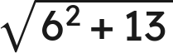 1 pt
7
Finish under the bar: 36 + 13 = 49.
b. 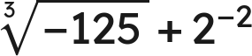 1 pt
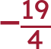
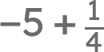.
c. 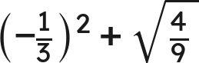 1 pt
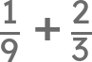.
Scoring: a 1 · b 1 · c 1 = 3 points.

11. A square patio of side 14 feet is sealed at 2.40 dollars a square foot, with a flat 85 dollars for delivery.
a. Write an expression for the total cost. 1 pt
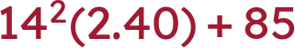
The rate multiplies the area; the flat fee does not. An expression that charges 85 on every square foot does not earn the point.
b. Find the total cost. 1 pt
555.40 dollars
196(2.40) = 470.40, then + 85.
Scoring: a 1 · b 1 = 2 points.

12. Which is the value of 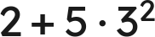 ? 1 pt
○ A. 32
● B. 47
○ C. 63
○ D. 289
B
Scoring: 1 point.

13. Select ALL of the expressions whose value is 6. 1 pt
☐ A. 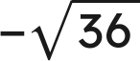
☒ B. 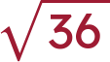
☐ C. 36 ÷ 3 · 2
☒ D. 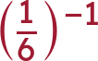
☒ E. 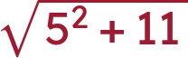
☒ F. 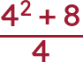
B, D, E and F
All four correct and nothing else for the point.
Scoring: 1 point.

14. Nadia writes . Explain why she is wrong, and give the correct value. 1 pt
The radical bar is a grouping symbol, so 25 + 144 is finished before the root is taken: 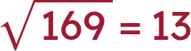. The root of a sum is not the sum of the roots.
The point needs the reason AND the value. '13' alone does not earn it, and neither does 'she added wrong'.
Scoring: 1 point.

15. A square tile has an area of 169 square inches. A second square tile has a side twice as long as the first. What is the area of the second tile? 1 pt
676 square inches
TRANSFER ITEM — not on the practice test. Same benchmark, a surface nobody rehearsed. The side of the first is 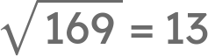, so the second has side 26 and area 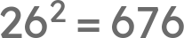. Doubling a side and asking for the new area appears on no review and in no question bank; a student who doubles the area and writes 338 has not gone through the side.
Scoring: 1 point.

Score Tracker
Benchmark | Questions | Possible | Earned
MA.8.NSO.1.5 | 1, 2, 3, 4, 5, 6 | 12
MA.8.NSO.1.6 | 7, 8 | 4
MA.8.NSO.1.7 | 9, 10, 11, 12, 13, 14, 15 | 13
Total |  | 29

If an earlier part is wrong, a later part still earns its point when the right operation is applied to your own earlier answer — but only if that work is on the page. Nothing is weighed and nothing is arguable: apply the part's operation to the student's own earlier value and tick if that is what is written.

